

Lab # 05
Mobile Application Development – I Fall 2024



Course Instructor: Mr. Qaisar Khan

Lab Instructor | Mr. Muhammad Ahmed
Student Name | Muhammad Taha
CMSID | 518133
Department | Computer Science
Semester | 4th

Lesson Set 5

First Flutter Application and Understanding Stateless and Stateful Widgets

Purpose 1. To introduce students to the Flutter framework and its fundamental concepts.
- To provide hands-on experience in building basic Flutter applications.
- To help students understand the difference between stateless and stateful widgets.
- To explore the usage of common Flutter widgets such as `Text`, `Icon`,
`Image`, `Row`, `Column`, and `Button`.
- To enhance students' understanding of UI design and state management in mobile applications.
- To build students' confidence in developing simple interactive applications using Flutter.

Procedure 1. Students should read the Pre-lab Reading assignment before coming to the lab.
- Students should complete the Pre-lab Writing assignment before entering the lab.
- In the lab, students should complete Labs 5.1 through 5.4 in sequence. Your instructor will give further instructions on grading and completing the lab.
- Students should complete the set of lab tasks before the next lab and get them checked by their lab instructor.

Contents | Pre-requisites | Completion Time | Page Number
Pre-lab Reading Assignment | - | 20 min | 3
Pre-lab Writing Assignment | Pre-lab Reading | 10 min | 4
Lab 5
Lab 5.1  Understanding flutter widgets | Pre-lab reading | 30 min | 5
Lab 5.2  Lab Tasks | Create first flutter app | - | 9

PRE-LAB READING ASSIGNMENT
Introductio n | In this lab, you will take your first steps into the world of Flutter by building a basic Flutter application. Understanding the fundamental concepts of stateless and stateful widgets is key to becoming proficient in Flutter app development. Widgets are the building blocks of Flutter applications, and distinguishing between stateless and stateful widgets will allow you to manage the app’s state effectively.
What Are Widgets? | In Flutter, everything is a widget. A widget is essentially a description of part of a user interface (UI). From buttons, text, and images to the entire layout structure, they are all widgets in Flutter. Widgets are nested within one another, which means that the UI of your application is built by composing widgets together.  Stateless Widgets  Stateless widgets are widgets that do not store any state. They are immutable, meaning their properties cannot change once they are built. Stateless widgets are often used for static parts of the UI, such as text labels, icons, and simple layout elements that don’t need to be updated dynamically.  Stateful Widgets  Stateful widgets, on the other hand, are widgets that can change their state during the app's lifecycle. They are mutable, which allows you to update their state and have the UI reflect these changes. For instance, a button that increments a counter whenever it’s pressed would be a stateful widget, as its state (the counter) changes.  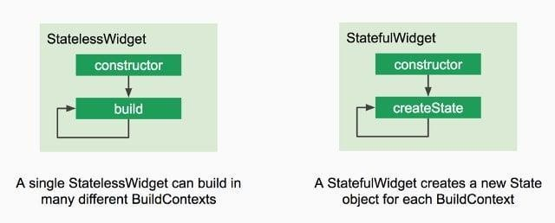
Common Flutter Widgets | Below are some commonly used widgets in Flutter:  - Text: Displays a string of text.  - Container: A box model element used for styling.  - Row/Column: For arranging widgets horizontally or vertically.  - ListView: Scrollable list of widgets.  - Stack: Layers widgets on top of one another.  - Padding: Adds space around a widget.  - Icon: Displays an icon  Stateless Widget Example

import 'package:flutter/material.dart'; void main() {
runApp(MyApp());
}
class MyApp extends StatelessWidget { @override
Widget build(BuildContext context) { return MaterialApp(
home: Scaffold(
appBar: AppBar(title: Text('Stateless Widget Example')), body: Center(child: Text('Hello, World!')),
),
);}}

This simple application is built using a `StatelessWidget`, where the text "Hello, World!" will be displayed at the center of the screen.

Stateful Widget Example import 'package:flutter/material.dart'; void main() {
runApp(MyApp());
}
class MyApp extends StatefulWidget { @override
_MyAppState createState() => _MyAppState();
}
class _MyAppState extends State<MyApp> { int counter = 0;
void incrementCounter() { setState(() {
counter++;
});}
@override
Widget build(BuildContext context) { return MaterialApp(
home: Scaffold(
appBar: AppBar(title: Text('Stateful Widget Example')), body: Center(
child: Column(
mainAxisAlignment: MainAxisAlignment.center, children: <Widget>[
Text('Button tapped $counter times'), ElevatedButton(
onPressed: incrementCounter, child: Text('Tap me!'),
),],),),),); }}

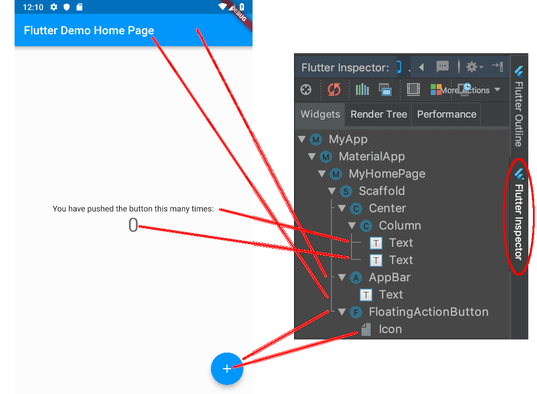
This example demonstrates a `StatefulWidget` where the counter is incremented each time the button is pressed.
Common Widget Usage
In real applications, you will frequently use widgets like `Text`, `Icon`, `Image`,
`Row`, `Columns`, and more. These widgets are vital for building the structure and UI of your app.
- Text Widget: Displays text.
- Image Widget: Displays an image from a URL or local asset.
- Container Widget: Used for padding, margin, and decoration.
- Button Widgets: Such as `ElevatedButton`, `TextButton`, and `IconButton`, allow user interaction.

PRELAB WRITING ASSIGNMENT
- What is the main difference between stateless and stateful widgets in Flutter?
Ans: Stateless widgets are immutable, meaning their data cannot change once created, and they do not rebuild unless the parent rebuilds them. Stateful widgets can change their data during runtime and rebuild themselves when their state changes.
- Why do we use `setState()` in a stateful widget, and what is its significance?
Ans: We use setState() in a stateful widget to notify Flutter that the internal data has changed. Its significance is that it triggers the widget to rebuild so the updated data is reflected on the screen.
- Explain the purpose of the `MaterialApp` widget in Flutter.
Ans: MaterialApp is the root widget in most Flutter applications. It provides essential features like navigation, themes, routes, and overall app configuration based on Material Design.
- Describe how a `Column` widget differs from a `Row` widget.
Ans: A Column widget arranges its children vertically from top to bottom, while a Row widget arranges its children horizontally from left to right.
- How would you use the `Image` widget to display an image from a local asset in Flutter?
Ans: To display an image from a local asset, first add the image path in pubspec.yaml under assets. Then use Image.asset('assets/image_name.png') inside your widget to show the image.

Lab 5.2 | Lab Tasks

Task 1: Build a Static Company Dashboard
Requirements:
- Create a new Flutter project.
- Remove default counter code.
- Used different flutter widgets and all should be vertically centered
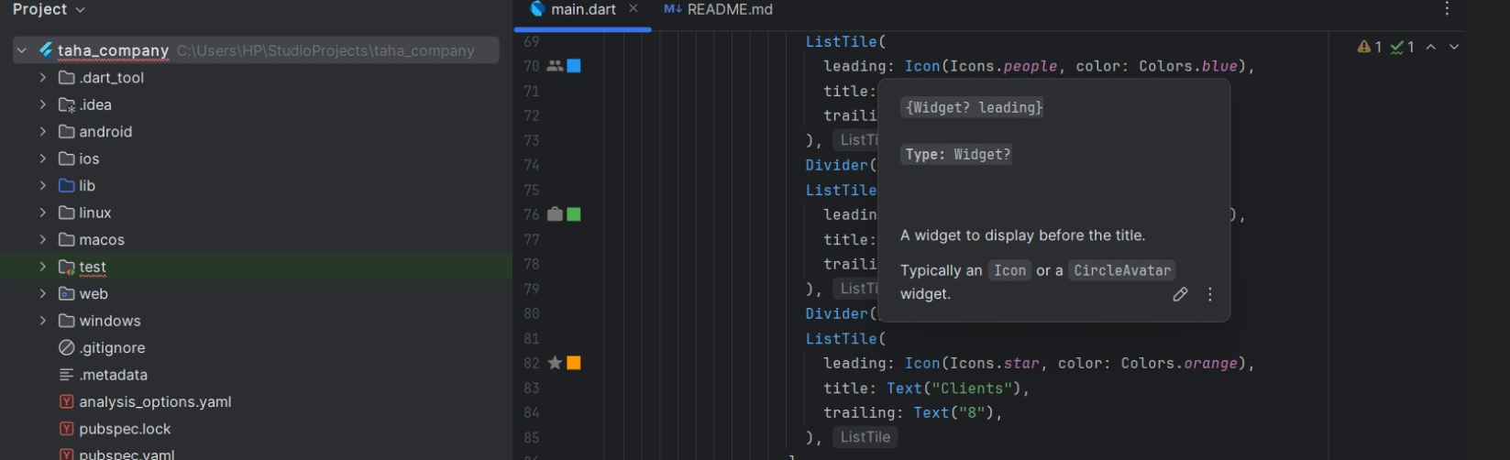
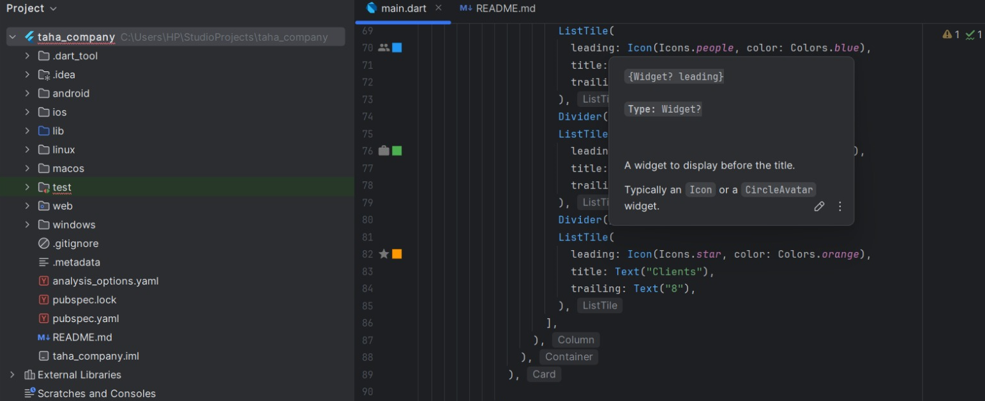
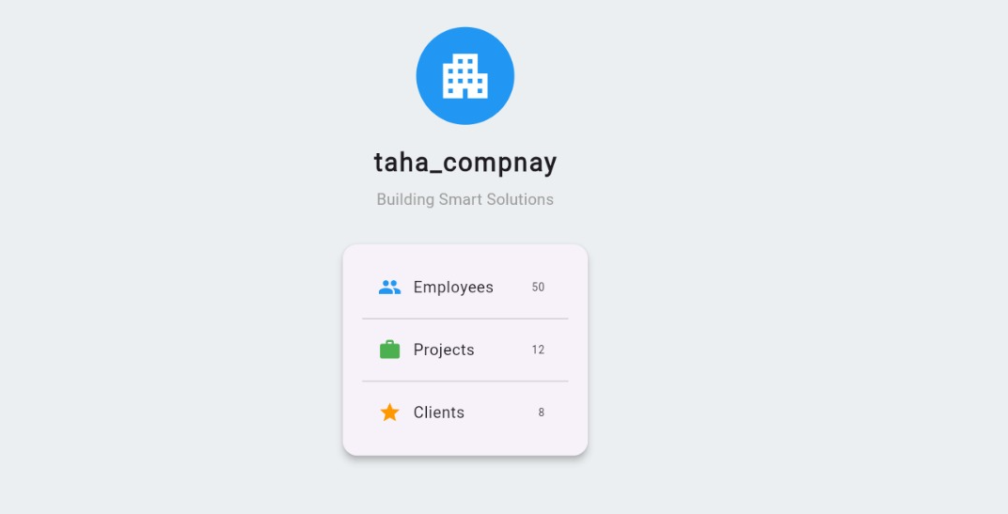

Task 2: Convert App to Stateful (Interactive Counter)
Requirements:
- Convert the main widget to StatefulWidget.
- Add an integer variable
- Add a button:
- On press → increment counter.
- Display updated count on screen.
- Use setState() properly.
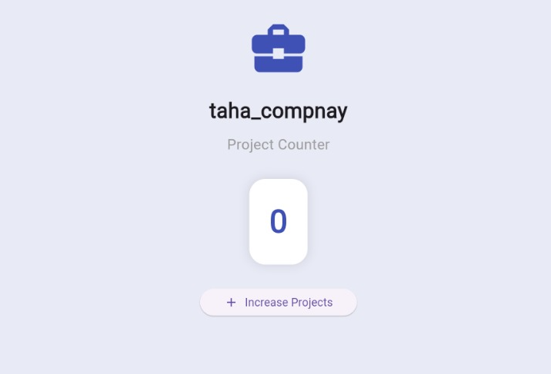
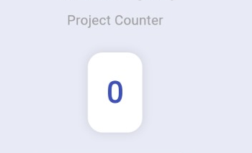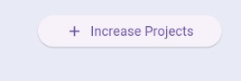
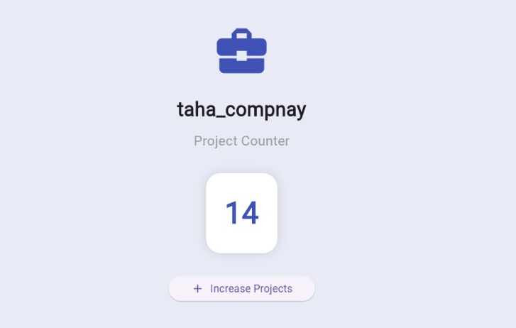

To Receive Credit

- By showing up on time for lab, working on the lab solution, and staying until the end of the class period, only then you can receive full credit for the lab assignment.
- Comment on your program heavily. Intelligent comments and clean, readable formatting of your code account for 20% of your grade.
- The lab time is not intended as free time for working on your programming/other assignments. Only if you have completely solved the lab assignment, including all challenges, and have had your work checked off for completeness by your TA/Lab Engineer should you begin the programming/other assignments.

